Муниципальное бюджетное общеобразовательное учреждение города Ростова-на-Дону «Гимназия №34 имени Чумаченко Д.М.»

Индивидуальный проект

Тема: “STRESS AND ITS IMPACT ON HUMAN BODY”

Автор проекта: Третьякова Дарья
Руководитель проекта: Романовская Татьяна Дмитриевна
Консультант: Апухтина Елена Алексеевна

Ростов-на-Дону
2021 год

Outline
Introduction………………………………………….…..1
Main bulk: History of stress…………………………..…1 Definition «What is stress?»………………1-2
Functioning of stress………………………2-3 Hypothesis……………………………..….3-4
The scientific methods…………………….4-5
Results ............................................................5
Conclusion……………………………………………….6

Introduction: Stress can make us anxious, sad, angry or worried but it also leads to a whole host of negative effects on our bodies. We all feel stressed but every individual experiences it differently Topicality: Stress is an up-to-date problem because there are a lot of sources of stress in our modern world. As an example we can name the stress caused by Covid-19 Project goal: Stress plays a great role in our life and I want to learn how to deal with its effects The aims of project : 1)To learn about definition of stress 2)To test a hypothesis about stress impacting on human activities 3)To take some experiment part Hypothesis : « A man is able to deal with stress by himself without any medical help » History of Stress: Contrary to what we might think, the term stress began to be used many centuries ago. Already in the fourteenth century it was used to refer to negative experiences such as difficulties, adversities or suffering that lived the person. It was used in the seventeenth century when the concept of stress applied in a habitual way by physicists and engineers, in order to denominate a characteristic of the solid bodies. This characteristic refers to the internal force present in an area on which an external force acts that can distort that solid state. In 1926, Hans Selye introduced the term in the field of health to refer to a general response of the body to a stressor or stressful situation. What is stress? It is a reaction of the body when it experiences changes. It may respond emotionally, mentally, and physically to the changes. In fact, science considers it as the body’s normal reaction. Positive changes can also cause you to be stressed: it could be a promotion at work or even childbirth.
There are two groups of stress :

Positive Stress
Contrary to what we usually think, stress is not always negative or harmful to the person. This type, also called eaters, is the one that appears when the person feels pressured, but interprets that the consequences of the situation can be positive. This type of stress is associated with positive emotions such as joy, satisfaction or motivation.

Negative Stress
This type also called distress is the one that is related to the anticipation of possible negative consequences.Disorder is associated with negative emotions, such as sadness, anger, and in some cases anxiety. Headaches and persistent migraines. Frequent chest pain and shortness of breath. Some heart problems have also been associated.

In 1956, Hans Selye proposes that the stress response consists of three differentiated stages:
First Stage:Alarm--emergency signal to brain, body gets more energy and works work faster. Accompanied by heavy breathing, faster heart rate, sweating, high blood pressure.
Second Stage: Resistance--Reduction in energy levels takes place, so feel exhausted but at the same time anxious and forgetful (because of whatever is still worrying you).
Third Stage: Exhaustion--Completely drained of all energy and just tired. No drive to work, carry on with errands, or live. This stage is a breakdown of your mental and physical system which can have severe consequences (raised blood pressure levels, ulcers, even Heart disease).

Functioning of stress
1.Conservation and maintenance
2.Mobilization of resources
3.Adaptation

When we think about the stress it’s important to be mindful of its effects not just on our moods but also on our bodies. If we understand how our body reacts to stress we will develop some mechanism that helps us remain calm and physically healthy. For example it’s harder for us to get sleep at night, it’s harder for us to find time in our schedule to exercise and take care about ourselves, we attend to eat highly fat food.

Hypothesis:
The hypothesis is that “A man is able to deal with stress by himself without any medical help”. It is expected that a great number of people will support the idea of hypothesis. The purpose is to test a hypothesis about stress impacting on human activities. In case the hypothesis is not verified it is planned to repeat the experiment

The scientific methods:
The research project will be run with the help of survey and experiment.

Survey:
Survey was hanged between students of 7,9,11 grades. I have lent notices to the students and they wrote their answers.

The crucial goals were to know :

-How often students fell stressed
-How stress influences on their life
-To know their own opinion if person is capable of managing with stress by own efforts
-How do they struggle with stress.
The results of my public opinion poll are presented in the form of line graphs

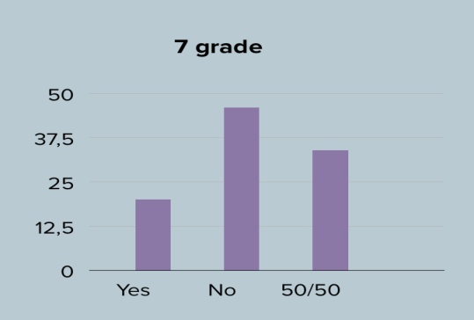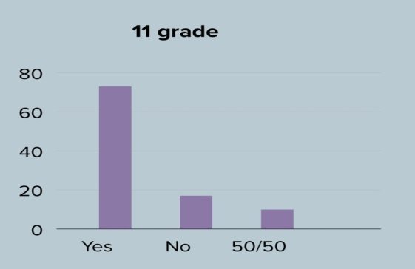

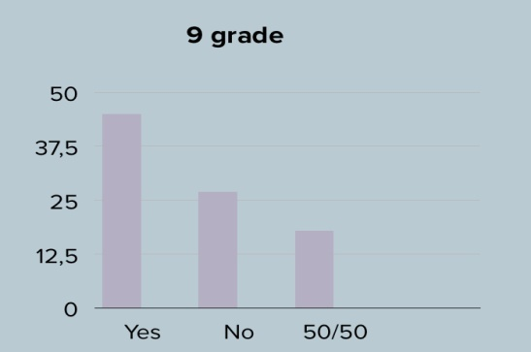

Experiment:
So, to say about experiment part of my topic I asked 10 students from 7 grades to involve in my experiment. I have told them about the methods of stress control and their task was to have firsthand knowledge. After all, they must share with me their impressions.The main aim was to know how some methods against the stress will help to overcome stressful moment of their life.

Well, the methods are:
1) Deep breathing
2) Meditation
3) Aroma fumes
4) Yawning
5) Doing sport
6) Smiling often
7) Healthy eating

The observed and recorded facts analyzed and drawn in the form of circle graphs

Conclusion: I identify more information about stress and obtain historical meaning of it as students in my school suffered from it .To sum up , I would also like to pay your attention to consequences of stress. Remember: If you have some anxious or depressed feelings you will refer to psychological help .Therefore anxious,weakness,irritability,distraction are primary symptoms that can provide you to serious diseases.

What happens to the body during stress?
The body’s autonomic nervous system controls your heart rate, breathing, vision changes and more. Its built-in stress response, the “fight-or-flight response,” helps the body face stressful situations.
When a person has long-term (chronic) stress, continued activation of the stress response causes wear and tear on the body. Physical, emotional and behavioral symptoms develop.

Physical symptoms of stress include:
Aches and pains.
Chest pain or a feeling like your heart is racing.
Exhaustion or trouble sleeping.
Headaches, dizziness or shaking.
High blood pressure.
Muscle tension or jaw clenching.
Stomach or digestive problems.
Trouble having sex.
Weak immune system.
Stress can lead to emotional and mental symptoms like:
Anxiety or irritability.
Depression.
Panic attacks.
Sadness.
Often, people with chronic stress try to manage it with unhealthy behaviors, including:
Drinking too much or too often.
Gambling.
Overeating or developing an eating disorder.
Participating compulsively in sex, shopping or internet browsing.
Smoking.
Using drugs.

How is stress diagnosed?
Stress is subjective — not measurable with tests. Only the person experiencing it can determine whether is it present and how severe it feels. A healthcare provider may use questionnaires to understand your stress and how it affects your life.
If you have chronic stress, your healthcare provider can evaluate symptoms that result from stress. For example, high blood pressure can be diagnosed and treated.
Causes
There are many different things in life that can cause stress. Some of the main sources of stress include work, finances, relationships, parenting, and day-to-day inconveniences.
Stress can trigger the body’s response to a perceived threat or danger, known as the fight-or-flight response. During this reaction, certain hormones like adrenaline and cortisol are released. This speeds the heart rate, slows digestion, shunts blood flow to major muscle groups, and changes various other autonomic nervous functions, giving the body a burst of energy and strength.
Originally named for its ability to enable us to physically fight or run away when faced with danger, the fight-or-flight response is now activated in situations where neither response is appropriate—like in traffic or during a stressful day at work.
When the perceived threat is gone, systems are designed to return to normal function via the relaxation response.﻿ But in cases of chronic stress, the relaxation response doesn't occur often enough, and being in a near-constant state of fight-or-flight can cause damage to the body.
Stress can also lead to some unhealthy habits that have a negative impact on your health. For example, many people cope with stress by eating too much or by smoking. These unhealthy habits damage the body and create bigger problems in the long-term

What are some strategies for stress relief?
You can’t avoid stress, but you can stop it from becoming overwhelming by practicing some daily strategies:
Exercise when you feel symptoms of stress coming on. Even a short walk can boost your mood.
At the end of each day, take a moment to think about what you’ve accomplished — not what you didn’t get done.
Set goals for your day, week and month. Narrowing your view will help you feel more in control of the moment and long-term tasks.
Consider talking to a therapist or a member of the clergy about your worries.
What are some ways to prevent stress?
Many daily strategies can help you keep stress at bay:
Try relaxation activities, such as meditation, yoga, tai chi, breathing exercises and muscle relaxation. Programs are available online, in smartphone apps, and at many gyms and community centers.
Take good care of your body each day. Eating right, exercising and getting enough sleep help your body handle stress much better.
Stay positive and practice gratitude, acknowledging the good parts of your day or life.
Accept that you can’t control everything. Find ways to let go of worry about situations you cannot change.
Learn to say “no” to additional responsibilities when you are too busy or stressed.
Stay connected with people who keep you calm, make you happy, provide emotional support and help you with practical things. A friend, family member, neighbor or member of your church can become a good listener or share responsibilities so that stress doesn’t become overwhelming.
How long does stress last?
Stress can be a short-term issue or a long-term problem, depending on what changes in your life. Regularly using stress management techniques can help you avoid most physical, emotional and behavioral symptoms of stress.

When should I talk to a doctor about stress?
You should seek medical attention if you feel overwhelmed, if you are using drugs or alcohol to cope, or if you have thoughts about hurting yourself. Your primary care provider can help by offering advice, prescribing medicine or referring you to a therapist.
People go through a lot of things. Many lead very challenging lives in this ever-changing and challenging world. Naturally, all these difficulties and challenges people experience will weigh down on people on some way or another but most especially through stress.
Stress is the body’s response to difficult situations. It is a surge of hormones and emotions inside the body as people try and think of ways of getting themselves out of those difficult situations. However, stress is subjective. This means that what can be stressful for someone may not necessarily be deemed stressful by somebody else.
There are many types of stress but not all of them are considered undesirable. As a matter of fact, some stress will increase your senses and help you avoid accidents or beat a deadline.
People have different ways of managing and coping with the stress they undergo. For example, there are those who would consider financially related issues stressful, while others would approach it as the fuel they need to push themselves out of their comfort zones. Often, that requires a strong will and mental approach that is not common.
Some people are not able to respond well to the pressures and demands of their day to day life. Their heart increases, their blood vessels constrict for longer than their body can manage, and gradually, these responses take a toll on the body.
Understanding what stress is and its different forms can provide you with insight on how you can avoid being overcome with stress. The following is a comprehensive breakdown of the three types of stress as outlined by the American Psychological Association.

Acute Stress
This is the most frequent type of stress reported among people. Acute stress is your body’s reaction to a new experience, challenge, or demand. It triggers a biological flight or fight response to certain situations such as a near-death experience, an argument with a loved one, or a mistake at work that could prove costly.
However, it is not always associated with negative experiences. The experience people have after riding on a roller coaster is acute stress and can train your mind and body on how to react to future stressful situations.

Episodic Acute Stress
This type of stress is simply constant acute stress. People who seem to always undergo a crisis can be said to have episodic acute stress. They are usually anxious, irritable, and are very quick to anger. People who seem to always look at the bad side of things can be said to have this kind of stress. People with this type of stress find it hard to change because their brain has adapted to stress as a part of their daily life.

Chronic Stress

Chronic stress is basically acute stress that has not been resolved and continues to build up over time. Chronic stress is constant and can grow from things such as poverty, an unhappy marriage or family, or a bad job. Chronic stress, unfortunately, can result in serious health risks such as heart disease and depression.
Conclusion: It’s important to find ways to cope with stress and manage it. Meditation is becoming increasingly popular to help the body relax. Find what works for you as stress can be physically harmful to the body and eventually takes its toll.

Links
https://my.clevelandclinic.org/health/articles/11874-stress
https://www.psychreg.org/types-of-stress/
https://explorable.com/what-is-stress
https://www.stress.org/what-is-stress-blog
https://moluch.ru/archive/270/61921/
https://www.medicalnewstoday.com/articles/stress-effects-on-the-body
https://www.mayoclinic.org/healthy-lifestyle/stress-management/in-depth/stress-symptoms/art-20050987
https://www.helpguide.org/articles/stress/stress-symptoms-signs-and-causes.htm
https://www.bbc.com/future/article/20190813-burnout-anxiety-stress-proof-relief
https://www.researchgate.net/publication/316919424_Stress_and_Human_Body_System_Reaction_-_A_Review

